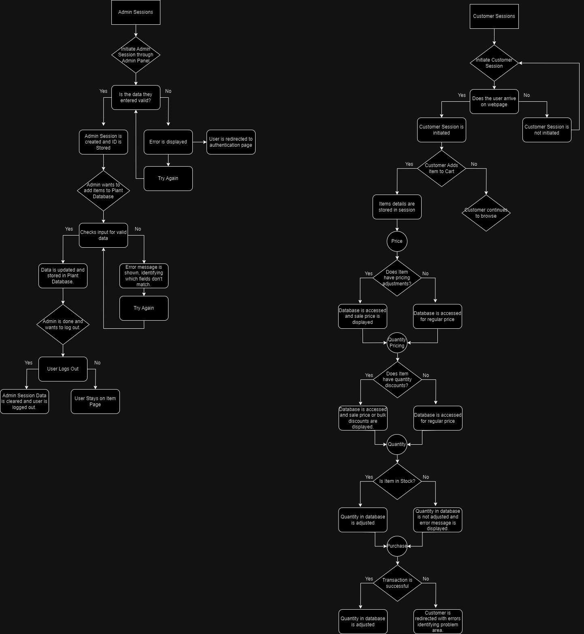

The image above shows a flowchart for the Admin Session of my Website Project.

The image below shows a flowchart of the Customer Session of my Website Project.

4: Submission represents work of the highest quality, and goes beyond any written or verbal requirements in terms of what was accomplished

3: Submission meets expectations of doing the work as requested, and is complete and accurate

2: Aspects of submission are incomplete, or finished in a cursory way

Self Assigned Mark: 3/4

